

Internet of Things 33 (2025) 101660
Contents lists available at ScienceDirect

Internet of Things
journal homepage: www.elsevier.com/locate/iot


Research article
Enhancing face recognition attendance system utilizing real-time face tracking
Emmanuel Bugingo ^{a,b,∗}, Obed Imbahafi ª, Athnatius Caius Umeonyirioha ^{c}, Tohari Ahmad ^{d}, Ntivuguruzwa Jean De La Croix ^{d}, Anne Marie Uwumuremyi ª
a School of Computing and Information Technology, University of Kigali, Rwanda
b College of Business and Economics, University of Rwanda, Rwanda
c School of Computer Science and Technology, Hangzhou Dianzi University, China
d Department of Informatics, Institut Teknologi Sepuluh Nopember, Indonesia

A R T I C L E I N F O A B S T R A C T

Keywords:
Real-time face tracking Attendance system
Convolutional neural networks Firebase
Visual analytics
Manual roll calls and existing biometric attendance systems, which capture attendance only at the start or end of class, are prone to inaccuracies such as proxy attendance and fail to monitor students’ presence throughout the sessions in Schools. This study proposes an enhanced face recognition attendance system utilizing real-time face tracking to ensure accuracy and reliability in attendance tracking. The system captures facial data using OpenCV for detection and a CNN- based library for recognition, logging attendance at 30 min intervals. A minimum presence of 80% of the session must be marked present. Attendance records are synchronized in real time using Firebase, and insights are generated using Plotly for visual analytics. The system achieves a recognition accuracy of 94% under optimal conditions and demonstrates robustness under varying environments. Comparative analysis with existing algorithms highlights its improved scalability and usability, significantly advancing over traditional methods.

Introduction

Managing attendance in educational institutions has always been a critical task for administrators and lecturers [1,2]. Traditional attendance methods, such as manual roll calls or physical sign-ins, have been widely used but are time-consuming, prone to errors, and susceptible to fraudulent practices like proxy attendance [3,4]. The advent of biometric technologies, particularly facial recognition, has opened new possibilities for streamlining attendance processes in educational environments, offering contactless, efficient, and scalable solutions [5]. However, implementing these advanced systems poses unique challenges, such as maintaining accuracy in diverse environments and ensuring the system’s usability at scale.
Despite their utility, traditional methods of attendance management face significant limitations. For example, manual roll calls often result in students signing in for absent peers or leaving class after being marked as present. Even digital solutions like Management Information Systems (MIS) have failed to eliminate such inefficiencies, as they still depend on manual inputs. Attempts to mitigate these issues using biometric systems, such as fingerprint scanners, have also fallen short due to logistical challenges, including long queues for verification and physical interaction requirements that reduce scalability [6–10]. These problems highlight the need for more robust and efficient attendance management systems tailored to modern educational settings.

∗ Corresponding author at: College of Business and Economics, University of Rwanda, Rwanda.
E-mail addresses: ebugingo@uok.ac.rw, e.bugingo@ur.ac.rw (E. Bugingo), 2201000581@uok.ac.rw (O. Imbahafi), m2005002@hdu.edu.cn
(A.C. Umeonyirioha), tohari@its.ac.id (T. Ahmad), 7025221024@student.its.ac.id (N. Jean De La Croix), DBBITMS2012936@uok.ac.rw (A.M. Uwumuremyi).

https://doi.org/10.1016/j.iot.2025.101660
Received 21 February 2025; Received in revised form 15 May 2025; Accepted 22 May 2025
Available online 9 June 2025
2542-6605/© 2025 Elsevier B.V. All rights are reserved, including those for text and data mining, AI training, and similar technologies.

To address these challenges, researchers have proposed various biometric attendance solutions. Among these, facial recognition systems have gained popularity for their contactless nature and ability to automate attendance tracking. For example, Ogbuju et al. [11] developed the DL/acer system, which employs a Faster Region Convolutional Neural Network (FRCNN) to achieve high accuracy (97%–99%) in real-time attendance tracking. Similarly, Khan et al. in their paper [12], utilized OpenCV and Face API to design an automated system that simplified attendance management while reducing manual interventions. However, many systems capture attendance at static intervals, such as the beginning or end of a session, leaving them vulnerable to inaccuracies and fraudulent practices.
These existing solutions, while promising, exhibit several limitations. Systems like DL/acer and Khan’s real-time face recognition system [12] do not continuously monitor attendance throughout the session, enabling students to be marked present despite not attending the entire class duration. Moreover, their performance often depends on controlled environments, struggling with variability in lighting, camera angles, or crowded classrooms. Furthermore, most systems lack seamless integration with databases for real-time data updates or analytics tools to provide actionable insights, reducing their efficiency in practical deployments [13].
Our proposed system addresses the limitations of existing attendance systems by introducing a real-time, face-recognition-based solution with continuous tracking capabilities. The system leverages OpenCV for face detection and Convolutional Neural Networks (CNNs) for accurate face recognition, recording attendance every 30 min to ensure compliance with an 80% session attendance requirement. Attendance data is synchronized in real time using Firebase, and visual analytics are generated through Plotly to support informed decision-making. The system contributes to:
- Improving the accuracy and reliability of attendance tracking.
- Reducing the risk of proxy attendance through continuous monitoring.
- Enhancing scalability and usability for diverse educational settings by providing a user-friendly website built with Flask, enabling administrators and lecturers to navigate and utilize the system efficiently.
- Providing actionable insights through visual analytics for better attendance management.

So this paper is structured to provide a comprehensive overview of the development and enhancement of a real-time face recognition-based attendance system and is organized as follows: Section 1 provides an overview of the background, the general problem, existing solutions with their limitations, proposed contributions, and objectives of the study, establishing the context for the proposed solution. Section 2 reviews advancements and limitations in existing face recognition-based attendance systems, identifying gaps addressed by this research. Section 3 details the enhanced attendance system’s architecture, methodology, and key components. Section 4 presents the testing environment, discusses the evaluation and results, and finally, Section 5 concludes this paper.

Related works

The empirical review of face recognition-based attendance systems highlights significant advancements in automating attendance management. Researchers have explored a variety of approaches to improve accuracy [12,14–16], scalability [17–19], and usability in educational settings.
In 2014, the research by Zainal et al. [6] introduced a portable classroom attendance system using fingerprint biometrics. The system emphasized portability and security by incorporating a fingerprint scanner and data encryption techniques. However, it required physical interaction with the device, limiting scalability in large classrooms and introducing hygiene concerns. While innovative, the approach lacked the scalability and contactless features necessary for modern educational institutions. These limitations underline the need for advanced, contactless solutions like face recognition systems.
In their paper [20], Dev and Patnaik investigated the performance of various facial recognition techniques, including K-Nearest- Neighbors (KNN), Convolutional Neural Networks (CNN), and Support Vector Machines (SVM). Their study revealed that KNN achieved the highest accuracy of 97%, making it suitable for real-time systems. CNN demonstrated robust real-time data processing with a 95% accuracy rate, while SVM underperformed with an 88% accuracy due to higher computational complexity. These findings validated the potential of machine learning models like CNN for efficient and accurate attendance management.
Yang and Han (2020) [13] focused on real-time video processing for attendance systems, achieving an accuracy rate of 82%. Their system employed facial recognition to update attendance at the start and end of sessions, reducing manual tasks by 60%. However, the reliance on static snapshots limited its ability to monitor attendance throughout the session. This approach underscores the need for continuous real-time tracking to address such limitations.
Another 2020 study by Rusdi et al. [21] demonstrated the effectiveness of well-maintained image libraries and robust hardware in achieving high accuracy for facial recognition systems. Their solution achieved up to 99% accuracy, highlighting the importance of hardware optimization and system maintenance for reliable performance. While their results were impressive, the lack of continuous tracking left room for improvement.
Ogbuju et al. (2020) proposed DLFacer [11], a system leveraging Faster Region Convolutional Neural Network (FRCNN) for real- time face recognition. The system achieved an accuracy rate between 97% and 99%, demonstrating the potential of deep learning for automating attendance. However, the system recorded attendance only at fixed intervals, leaving it vulnerable to proxy attendance during other session parts.
Based on the existing papers, although significant progress has been made in face recognition-based attendance systems, specific challenges remain unaddressed. Many existing solutions rely on static attendance snapshots (start and end of sessions) or lack continuous monitoring, making them prone to inaccuracies such as proxy attendance. Furthermore, while high accuracy has been

demonstrated in controlled environments, scalability and robustness in real-world scenarios remain challenging, particularly under varying lighting conditions.
This research aims to bridge these gaps by proposing a continuous real-time attendance system that tracks student presence throughout the session, ensuring a minimum threshold for attendance compliance. Integrating technologies like OpenCV, CNN, and Firebase provides a scalable and reliable solution tailored for dynamic educational settings.

Proposed system

The proposed system is a real-time face recognition-based attendance system designed to automate and improve the accuracy of attendance tracking at the University of Kigali. The system continuously captures, recognizes, and records student attendance throughout class sessions by leveraging advanced computer vision techniques, Convolutional Neural Networks (CNNs), and real- time data processing. This system eliminates the need for manual roll calls and addresses the issue of proxy attendance, providing a robust and efficient solution to traditional attendance management.

  - System architecture

The architecture of the proposed system consists of several key components: face detection, face recognition, real-time data processing, database management, and visual analytics. Initially, the project intended to utilize a sliding high-definition (HD) camera system to traverse the classroom and capture students from multiple angles, thereby ensuring comprehensive attendance tracking. This idea was inspired by the study by Ubong Essien and Godwin Ansa [22], who developed a cost-effective single-camera rail system integrated with face recognition technology. Their system employed an ESP8266 microcontroller to calculate stop positions for the camera based on parameters such as the field of view angle, maximum object distance, and rail length. The camera was moved along the rail using a stepper motor, with images captured at each stop position and processed using OpenCV before being transferred to the face recognition system. Their results demonstrated that this approach effectively eliminated blind spots and ensured complete coverage of classroom participants.
Building upon this foundation, the proposed project aimed to enhance this system by employing an HD camera and refining the rail mechanism for greater adaptability and precision. This improvement would have allowed seamless integration with real-time attendance systems, leveraging IoT technologies such as Raspberry Pi or Arduino for mobility and system synchronization. Camera calibration was also planned as a complementary feature to optimize detection accuracy. However, this concept was deferred for future development due to the complexity of designing and implementing such an advanced system within the project timeline.
As a result, the current implementation uses a computer webcam for real-time video capture. To ensure full classroom coverage, the webcam was manually repositioned during attendance tracking, capturing direct video feeds of students. This approach was necessary due to the webcam’s limited field of view, which could only capture three to four students per frame, depending on seating arrangements. Unlike some existing systems, we did not use students’ PC cameras, eliminating concerns regarding students without personal devices [23]. However, future enhancements could incorporate multiple fixed cameras with wide-angle lenses, Sliding HD cameras, or advanced tracking mechanisms to improve efficiency and reduce manual adjustments.
The Face Detection Module utilizes Haar Cascade Classifiers to detect student faces from the live video stream captured by the webcam. These classifiers apply a cascade of decision-making stages trained on positive and negative image samples, identifying facial features based on pixel intensity variations. Each classifier outputs a decision value based on the difference in pixel intensity between predefined regions of the image:
{1 if 𝑓 (𝑥) < threshold

ℎ(𝑥) =
(1)
0 otherwise

Here, f(x) represents the feature value, and the threshold is determined during training. The final classifier is constructed through the AdaBoost algorithm, which combines the results of several weak classifiers into a strong classifier:
∑𝑇
𝐻(𝑥) = 𝛼𝑡ℎ𝑡(𝑥) (2)
𝑡=1
Where 𝛼 t is the weight assigned to each classifier, and T is the total number of classifiers.
Once faces are detected, the Face Recognition Module processes the detected faces to identify students. Student identification is achieved using Convolutional Neural Networks (CNNs), which extract facial features and convert them into high-dimensional vectors known as embeddings. These embeddings are then compared with stored embeddings in the database to identify the student. The CNN applies convolution operations over the input image to generate feature maps:
∑𝑀 ∑𝑁
𝑦𝑖,𝑗 = 𝑤𝑚,𝑛 ⋅ 𝑥𝑖+𝑚−1,𝑗+𝑛−1 + 𝑏 (3)
𝑚=1 𝑛=1
Where 𝑦 i,j represents the output at position (i,j), w is the convolution kernel, and b is the bias. The feature maps are then passed through an activation function, typically ReLU:
ReLU(𝑥) = max(0, 𝑥) (4)

This process generates embeddings for each face, and recognition is performed by computing the Euclidean Distance between the embeddings of the detected face and those in the student database:
√√∑𝑛
𝑑(𝑥1, 𝑥2) = √ (𝑥1 − 𝑥2 )2 (5)
𝑖 𝑖
𝑖=1
If the distance between two embeddings is an equation below a predefined threshold (e.g., 0.6), the system considers them a match.
The Real-Time Data Processing Module ensures continuous attendance monitoring by capturing attendance at regular intervals throughout the class session, typically every 30 min. This allows for more dynamic tracking of student presence, addressing the limitations of systems that record attendance only at the beginning or end of class. A student is marked as present if they are detected for at least 80% of the class duration, calculated as:
𝑡presence
≥ 0.80 (6)
𝑡class
where T 𝑡𝑐𝑙𝑎𝑠𝑠 is the total duration of the class and t presence is the time the student is detected in the classroom.
The system employs Firebase for database management, providing real-time data synchronization and storage. Each student’s attendance data is updated automatically, with fields for student ID, name, course, session, and attendance status. Firebase’s real-time capabilities ensure that attendance records are always current and accessible to lecturers and administrators.
To complement the attendance management system, a visual analytics module is integrated using Plotly to generate visual insights. These insights include graphs and reports on attendance rates, absences, and trends. Such visual analytics help educators understand student engagement and attendance patterns, facilitating better decision-making and class management.
To evaluate the performance of the proposed system, the following metrics were utilized:

- Mean Recognition Accuracy: Average face recognition accuracy across all tested students.
∑𝑁 Accuracy

𝜇 = 𝑖=1 𝑖
𝑁
where 𝑁 is the total number of students.
- Standard Deviation: Measures the variability in face recognition accuracy.
(7)

√∑𝑁 (Accuracy − )2

𝜎 =
𝑖=1
𝑖 𝜇
𝑁
(8)

- Attendance Accuracy: Measures the proportion of correctly recorded attendances relative to the actual number of times students were present.

Attendance Accuracy = Correctly Recorded Attendances
Total Attendance Instances
- Accuracy (Recognition Rate): Proportion of correctly identified faces out of the total detected faces:
Accuracy = Number of Correctly Recognized Faces
Total Number of Detected Faces
- Precision: the proportion of correctly identified present students out of all students marked as present by the system.
Precision = True Positives True Positives + False Positives

(9)

(10)

(11)

- Recall: the proportion of correctly identified present students out of all students who were actually present for the entire lecture.

Recall = True Positives True Positives + False Negatives
- /1-Score: Harmonic mean of precision and recall:
F1-Score = 2 × Precision × Recall
Precision + Recall
- /alse Acceptance Rate (/AR): Percentage of incorrect matches:
FAR = Number of Incorrect Matches Total Number of Comparisons
- /alse Rejection Rate (/RR): Percentage of missed valid matches:
FRR = Number of Missed Matches Total Number of Valid Comparisons
(12)

(13)

(14)

(15)

  - System workflow

The workflow of the proposed system was designed to align with the university’s needs and its current session structure, which includes three distinct sessions: the Weekend Session, the Day Session, and the Evening Session. The Weekend Session runs on Saturdays and Sundays from 8:00 AM to 2:00 PM, with a one-hour break from 11:00 AM to 12:00 PM, and spans four weeks. The Day Session takes place from Monday to Friday, 8:30 AM to 11:30 AM, over three weeks. Finally, the evening session lasts over three weeks, from Monday to Friday, 6:00 PM to 8:30 PM.
The system begins with the Student Registration Phase, during which facial images of students are captured and processed to generate facial embeddings using Convolutional Neural Networks (CNNs). These embeddings are stored in Firebase Storage along with identification details such as the student’s ID, name, department, sex, and year of study. This registration process ensures that the system has the necessary data to recognize students during attendance tracking.
When a system administrator adds a new course, they specify the session in which it will be taught. Based on the selected session, the system automatically calculates and provides the exact dates the course will be conducted. This feature simplifies the scheduling process and ensures consistency with the university’s academic calendar.
Algorithm 1 Real-Time Face Recognition Attendance System

1: Initialize webcam feed and load Haar Cascade Classifier.
2: while video feed is active do
3: Capture frame and convert to grayscale.
4: Detect faces using Haar Cascade.
5: for each detected face do
6: Extract facial region and preprocess.
7: Generate embeddings using CNN.
8: Compare embeddings with stored database using Euclidean distance.
9: if match found then
10: Mark attendance.
11: end if
12: end for
13: end while
14: Log attendance in Firebase Database. 15: Generate visual analytics using Plotly. 16: End process when the session ends.

During the Attendance Tracking Phase, the system operates in real-time, capturing video streams of students in the classroom using a webcam. The Face Detection Module employs Haar Cascade Classifiers to identify faces in the video feed. These detected faces are then passed to the Face Recognition Module, which matches them against stored embeddings. Attendance is logged in real-time, with the system updating the Firebase database with details categorized by year, trimester, course, session, and date.
Attendance is taken at regular intervals of 30 min throughout the session. To be marked present, a student must attend at least 80% of the session. For instance, in the Weekend Session, which lasts five hours, attendance is taken 10 times, and a student must be present for at least eight intervals to be marked present. Similarly, in the Day Session, which lasts three hours, attendance is taken six times, requiring attendance in at least five intervals. In the Evening Session, which lasts 2.5 h, attendance is taken five times, with a minimum of four intervals required for a student to be marked present.
The system generates detailed attendance reports at the end of each session or any time. These reports include comprehensive information on attendance status, total counts, and attendance percentages for each student. Additionally, the system integrates the Plotly library to present interactive visual insights through the website. Users can access dynamic visualizations, including bar charts, pie charts, and line graphs, which depict attendance trends and patterns visually intuitively. This feature allows administrators and lecturers to review current attendance data or analyze session summaries conveniently, enabling more informed decision-making and efficient attendance management.
The pseudo-code (Algorithm 1) outlines the primary workflow of our system, illustrating the integration of its key components.

  - Technologies used

The proposed system integrates advanced technologies to deliver high-performance, real-time data processing, and insightful visual analytics. Each technology plays a distinct role, contributing to the system’s functionality. Below is a detailed breakdown of the technologies used:
- OpenCV: It is a popular open-source library for computer vision and image processing tasks. In this system, OpenCV was utilized for face detection, leveraging Haar Cascade Classifiers, a pre-trained model designed for object detection based on Haar-like features. The library processed video streams captured by the webcam to identify student faces in real-time, enabling the system to operate efficiently in diverse classroom environments [24].

- /ace Recognition Library: The face recognition component was implemented using the face recognition library, powered by deep learning techniques based on Convolutional Neural Networks (CNNs) [25]. This library was responsible for generating facial embeddings, unique mathematical representations of a face, and matching them against stored embeddings in the database. Using CNNs ensures high accuracy in identifying and verifying students’ identities.
- /lask: Is a lightweight and flexible Python web framework employed for developing the web interface of the system [26]. It
facilitated the creation of dynamic web pages for student registration, attendance tracking, and report generation. Flask’s modularity and support for integration with various Python libraries made it an ideal choice for building a robust and user-friendly system.
- /irebase Realtime Database: was used for handling attendance records. This cloud-hosted NoSQL database enabled real-time
synchronization of attendance data between the system and the database. The seamless integration of Firebase ensured that attendance logs were updated instantly as students were detected, allowing administrators and lecturers to access the most current information [27].
- Plotly: The system employed Plotly, a powerful data visualization library for visual insights. Plotly was used to create
interactive and visually engaging charts, such as bar graphs and pie charts, to depict attendance trends and patterns. These visualizations gave administrators and lecturers intuitive tools to analyze attendance data and make informed decisions [28].
- Numpy and Pandas: Is an essential Python library for data manipulation and analysis that was used to preprocess attendance
data [29]. Numpy facilitated numerical computations, while Pandas handled data structuring and filtering, ensuring efficient and accurate analysis of large datasets.
This combination of technologies forms an interconnected system: OpenCV detects faces in real-time from webcam feeds, while the face recognition library verifies identities using CNN-based embeddings. Flask is the backend framework that manages the communication between the web interface and Firebase, which stores attendance data. Plotly, in conjunction with NumPy and Pandas, generates insightful visualizations, presenting real-time analytics to users. This seamless integration ensures the system meets the university’s accuracy, usability, and scalability requirements.

  - Modules and features

The real-time face recognition system for student attendance tracking is designed as a modular architecture to ensure scalability, efficiency, and ease of management. Each module performs specific tasks, working together seamlessly to complete the attendance tracking workflow. Below is a description of each module, along with the alternatives considered and the rationale for the chosen approach:
- Video Capturing Module: This module handles real-time video streaming, capturing video frames from a selected input source to ensure smooth frame rates and high resolution for accurate processing. The output from this module serves as the input for the Face Detection Module. Multiple alternative technologies, such as a computer webcam, an Android smartphone camera, an HD IP camera, or an HD sliding camera, can handle video capturing. This study selected a computer webcam for its accessibility, affordability, and seamless integration with the system.
- /ace Detection Module: The Face Detection Module identifies faces in the video frames provided by the Video Capturing Module. It detects facial regions and outputs cropped images of detected faces for further processing by the Face Recognition Module. Researchers have developed different technologies that can be used to perform face detection, such as OpenCV, Dlib, and DeepFace. This study has considered OpenCV for its robust Haar Cascade Classifiers, which effectively detect facial regions. Additionally, Dlib was incorporated for its deep learning-based detectors and HOG features, enhancing detection accuracy under varied conditions. The combination ensures reliable performance.
- /ace Recognition Module: This module generates unique high-dimensional feature vectors (embeddings) for each detected face and matches them with a database of student embeddings to determine recognition. When it comes to face recognition, different technologies were developed, such as Convolutional Neural Networks (CNN), Eigenfaces, Fisherfaces, FaceNet, DeepFace, SVM, and an Adaptive Neurofuzzy Inference System. CNN was chosen for its exceptional capability in feature extraction and recognition tasks. Its optimized architecture ensures high accuracy and real-time processing, even when multiple faces are in the frame.
- Real-Time Attendance Reporting Module: This module facilitates real-time attendance tracking and integrates all admin- istrative features, such as session initiation, attendance monitoring, and record management. By combining Node.js, multiple Python-based frameworks, such as Flask and Django, can be used to report real-time attendance. This research selected Flask for its lightweight nature, ease of integration with Python-based libraries, and flexibility in building custom features. It provides an intuitive interface for administrators while ensuring system efficiency.
- Reporting and Insights Generation Module: This module generates attendance insights and visualizations for further analysis, and reporting can be achieved using different alternatives such as Plotly, Matplotlib, and Seaborn. Plotly was selected for its interactivity and ability to create dynamic, real-time visualizations. Its user-friendly nature allows administrators to derive actionable insights and export comprehensive reports effortlessly.
Table 1 shows all system modules:

Table 1
Modules and alternative choices used in research.
Modules Alternative choices

Video Capturing: Computer Webcam, Android Smartphone Camera, HD IP Camera, HD Sliding Camera
Face Detection OpenCV , Dlib, DeepFace
Face Recognition CNN , YOLO
Real-Time Attendance Reporting Flask, Django, Node.js
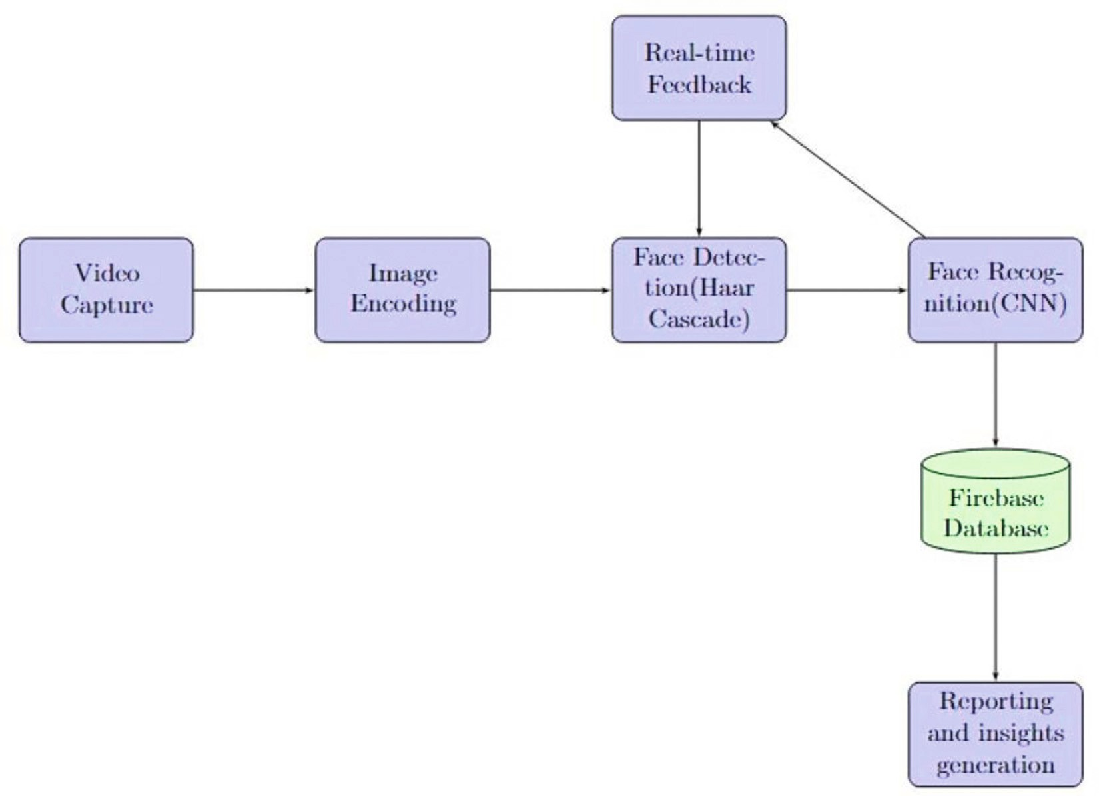
Reporting and Insights Generation Plotly, Matplotlib, Seaborn

/ig. 1. Detailed System Workflow: From Video Capturing to Real-Time Attendance Logging.

  - Implementation details

The system utilized several key Python libraries to implement face detection, recognition, and attendance tracking in real-time. Face Recognition, a Python library based on Idlib, was used to simplify the facial recognition process. This library provides easy-to- use functions for detecting and recognizing faces, and it leverages deep learning techniques to generate facial embeddings. Firebase Admin SDK was integrated into the system to manage real-time data storage and synchronization. Firebase’s real-time database capabilities allowed for immediate updates to attendance records, ensuring that the system could reflect changes instantly.
OpenCV (via the cv2 module) was utilized for image processing tasks to capture video streams from classroom cameras, perform face detection using Haar Cascade Classifiers, and prepare the images for further processing. The CV zone library, which builds on top of OpenCV, simplified many image manipulation tasks, such as drawing bounding boxes around detected faces and managing overlays.
In addition to these core libraries, Base64 and io were employed to encode and decode images between the client and server. These libraries enabled the efficient transfer of video frames by converting them into Base64 strings, which were transmitted over HTTP or WebSocket protocols—the os module handled file system operations, such as loading images and managing directories. At the same time, csv generated attendance reports in CSV format, which administrators could access and process. Finally, numpy was essential for handling matrix operations during image processing and face recognition, providing the foundation for mathematical computations. Below Fig. 1 shows a detailed system workflow.

  - Key differentiators of the proposed system

Several face recognition-based attendance systems have been developed to automate attendance tracking in educational institutions, with a focus on accuracy, scalability, and usability. However, existing solutions exhibit limitations, particularly in continuous monitoring, real-time data processing, and administrative functionalities. Zainal et al. [6] introduced a fingerprint- based attendance system that enhanced security but required physical interaction, making it unsuitable for large classrooms due to scalability and hygiene concerns. Similarly, Ogbuju et al. (2020) proposed DLFacer [11], an FRCNN-powered face recognition system that achieved high accuracy between 97% and 99%, yet it only captured attendance at fixed intervals, making it vulnerable to proxy attendance and early departures. Another study by Yang and Han (2020) [13] developed a real-time attendance system that relied on static image snapshots taken at the start and end of sessions, which limited its ability to track student presence throughout an entire class period. These approaches fail to ensure continuous monitoring, allowing students to be marked present despite missing significant portions of a lecture.
Our proposed system overcomes these limitations by implementing continuous attendance monitoring, where attendance is recorded every 30 min, and students must be present for at least 80% of the session to be considered present. This approach prevents proxy attendance and ensures active student participation throughout the lecture, addressing the shortcomings of previous systems. While Dev and Patnaik (2020) [20] found that CNNs performed well for face recognition, achieving a 95% accuracy rate, our system integrates OpenCV for real-time face detection and CNN-based recognition, maintaining an accuracy of 94% under optimal conditions and 85% in low-light environments. Unlike systems that rely on controlled settings for high recognition rates, our approach has been tested in real-world classroom environments, ensuring reliability under varying conditions. Furthermore, previous works such as Rusdi et al. (2020) [21] achieved up to 99% accuracy but lacked continuous tracking and real-time decision-making capabilities.
Beyond attendance recording, our system provides a web-based administrative dashboard, developed using Flask, that allows university staff to manage attendance efficiently. Unlike existing solutions that focus solely on face recognition, our system enables administrators to add courses based on available university sessions, register students and lecturers, assign students to courses, and automatically record attendance in real-time. Firebase integration ensures seamless synchronization of attendance records, while Plotly-powered visual analytics provide insights into attendance trends, helping institutions make data-driven decisions. These combined functionalities make our system not only an effective attendance management tool but also a scalable and user-friendly solution that enhances operational efficiency in educational settings.

  - Operational challenges

Initially, the system was designed to incorporate a sliding High-Definition (HD) camera to capture students from multiple angles, minimizing blind spots and improving recognition accuracy. However, due to time constraints and the unavailability of such a camera, we opted for a computer webcam for real-time video capture. While effective, this approach required manually repositioning the webcam to cover the classroom, as its limited field of view could only capture three to four students per frame, depending on seating arrangements. Additionally, variations in lighting conditions and camera angles occasionally impacted detection accuracy, necessitating minor adjustments. Another consideration was the system’s reliance on Firebase for real-time data synchronization, which was intentionally chosen for its scalability, reliability, and ability to ensure data integrity. Unlike offline databases, Firebase supports centralized attendance tracking across multiple university campuses, allowing administrators and lecturers to access records in real-time [30]. Given that universities increasingly rely on cloud-based infrastructures, Firebase was the most practical and future-proof solution, ensuring seamless accessibility while maintaining system efficiency.

Experiments and results discussion

This section evaluates the performance and robustness of the Real-Time Face Recognition-based Attendance System through a series of practical tests. These tests were designed to assess various aspects of the system, including face detection accuracy, recognition performance, attendance logging, system usability, and report generation. The tests were conducted using a personal computer’s webcam under typical classroom conditions, simulating real-world usage scenarios.

  - Test environment

The system was tested using the webcam of a personal computer to capture student video feeds in a classroom environment. For both the development and testing phases, the following specifications of the computer were used:
- Processor: Intel® Celeron® N4020 CPU @ 1.10 GHz, 1.10 GHz
- RAM: 4 GB
- System Type: 64-bit OS, X64-based processor
- Operating System: Windows 11 Home
- Device Model: Lenovo Ideapad 3 15IGL05

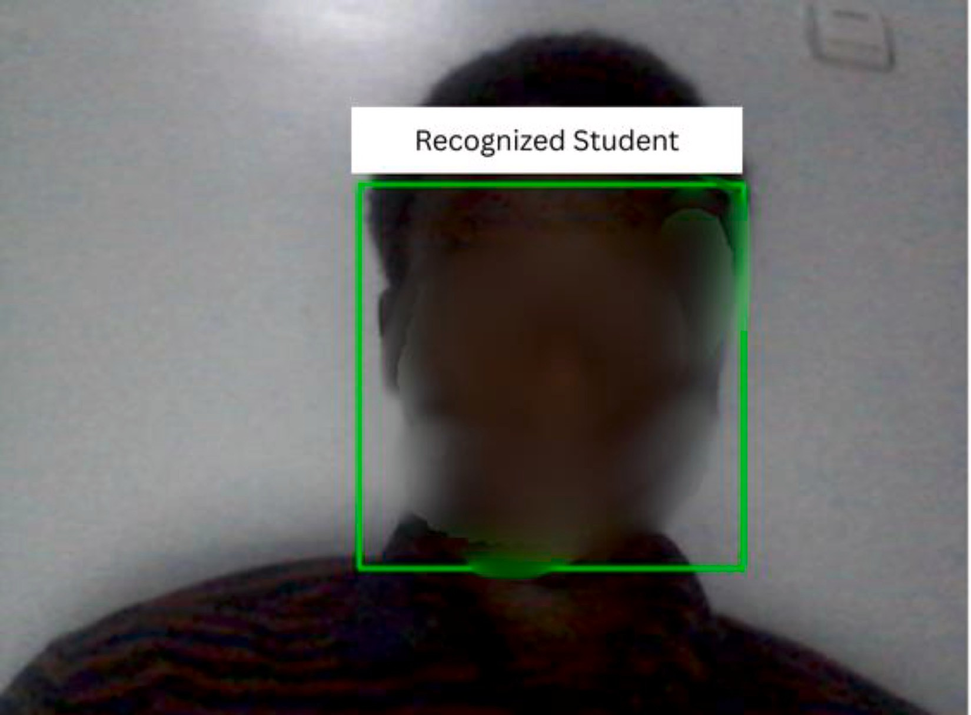

/ig. 2. Example of Face Recognition Output.

Table 2
Face detection accuracy under different lighting conditions.
Lighting condition | Successful detections | Failure rate
Normal Light | 95% | 5%
Low Light | 85% | 15%

Testing was conducted in a university classroom with typical classroom lighting conditions. The system used only the built-in webcam to capture video streams of students.
To ensure statistical reliability, the system was tested using 15 students enrolled in the software engineering course during the day session. These students participated in ten different test sessions to simulate real-world variations in attendance scenarios, allowing us to assess the system’s ability to record attendance across multiple individuals.
Fig. 3 shows the seating arrangement used during the test sessions, where a tall table at the front held the computer with a webcam. Students were seated in five rows, with three students sharing each table.

  - Test cases and results

The following practical tests were performed on the system to evaluate its capabilities:

    - Face detection accuracy test
The first test aimed to assess the system’s ability to detect faces in real-time from video streams correctly. This test was conducted under various conditions, including varying lighting levels (normal and low light) and face orientations (front, tilted, side). The results are shown in Table 2 and Fig. 2.
Results: The system showed a high detection accuracy of 95% under normal lighting conditions. However, under low-light conditions, the accuracy decreased to 85%, indicating that lighting plays a significant role in face detection performance.

  - Attendance and face recognition accuracy test

This test assessed the system’s accuracy in recognizing faces and matching them to the student database. The system displayed the recognized student’s name and a matching accuracy percentage.

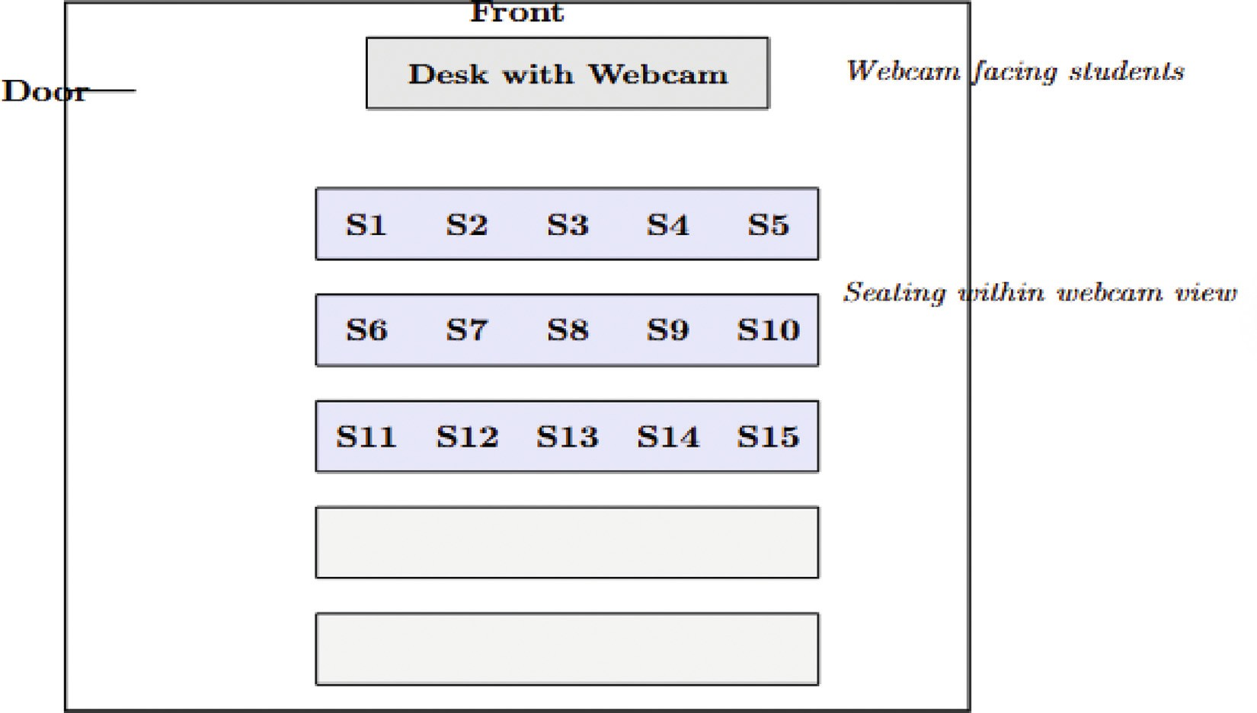

/ig. 3. Seating arrangement.

Table 3
Face recognition accuracy for different students.
Student name | Matched accuracy | Recognition success
Student 1 | 94% | Successful
Student 2 | 92% | Successful
Student 3 | 93% | Successful
Student 4 | 91% | Successful
Student 5 | 90% | Successful
Student 6 | 94% | Successful
Student 7 | 88% | Successful
Student 8 | 89% | Successful
Student 9 | 93% | Successful
Student 10 | 92% | Successful
Student 11 | 94% | Successful
Student 12 | 88% | Successful
Student 13 | 93% | Successful
Student 14 | 89% | Successful
Student 15 | 91% | Successful

Table 4
Attendance recording accuracy and performance metrics.
Metric Metric details

Overall Attendance Accuracy Accuracy: 92.5%

Precision: 91.0%

Recall: 90.5%
F1-Score: 90.7%
False Acceptance Rate (FAR) 2.5%
False Rejection Rate (FRR) 3.1%
Mean Processing Time per Frame 2.4 s

The system achieved a recognition accuracy ranging from 94% to 88% across the 15 tested students. The mean recognition accuracy was 91.3%, with a standard deviation of 2.1%, demonstrating stable recognition performance. The students presented in Table 3 were selected to illustrate performance variations, where the highest accuracy achieved was 94%, and the lowest was 88%. These results highlight the system’s reliability in recognizing faces while also demonstrating potential accuracy fluctuations due to lighting conditions, facial positioning, and seating arrangement.

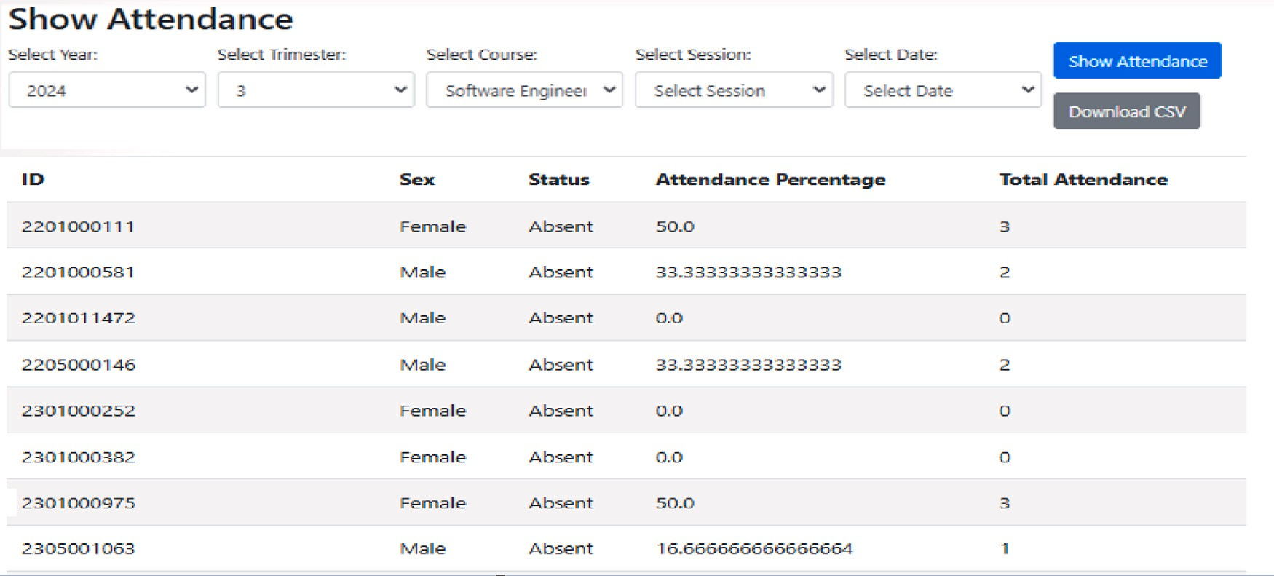

/ig. 4. Generated Attendance Report Showing Present/Absent Status.

Table 5
User interface usability feedback.
Task | Ease of completion (1-5)
Add New Course | 4.5
View Attendance Report | 4.8
Generate Visual Insights | 4.7

Table 4 summarizes the system’s attendance accuracy and key performance metrics. The overall attendance accuracy was 92.5%, meaning the system correctly recorded attendance in 92.5% of cases. The precision (91.0%) and recall (90.5%) values indicate a balanced performance, ensuring that falsely marked present students were minimized while correctly present students were identified accurately. The False Acceptance Rate (FAR) and False Rejection Rate (FRR) were low, at 2.5% and 3.1%, respectively, demonstrating minimal errors in classification. The system maintained an average processing time of 2.4 s per frame, ensuring efficient real-time attendance tracking.

    - Real-time attendance logging test
The next test focused on the real-time logging of student attendance after successful face recognition. The system logged attendance every 30 min and updated the records automatically. The Attendance Tracking Module was tested for its ability to accurately and promptly log attendance in the Firebase database. The system was designed to capture attendance at 30 min intervals throughout the session. Each recognition event was recorded with a timestamp, ensuring that students were marked as present only if they attended at least 80% of the class duration. The validation formula used was:
Presence of a student = 𝑡𝑝𝑟𝑒𝑠𝑒𝑛𝑐𝑒 ≥ 0.80 (16)
𝑡𝑐𝑙𝑎𝑠𝑠
This formula ensured that students could not leave the classroom early without impacting their attendance records. Tests confirmed that the system could reliably capture and store attendance data in real-time, with synchronization delays of less than
0.5 s between the recognition event and the database update; results are shown in Fig. 4.
Results: The system successfully logged students’ attendance in real-time, with no significant delays. The attendance data was updated at the scheduled intervals, ensuring accurate attendance tracking.

    - Attendance report generation and visual insights
After a class session, the system generated attendance reports showing the status of each student. Visual insights were provided using Plotly graphs to display trends in attendance (see Fig. 5).
Results: The attendance reports were generated accurately, showing the status of each student. Visual insights were clear and easy to interpret, with trends in student attendance displayed effectively through interactive graphs.

    - User interface and system usability
The website interface was evaluated to assess the system’s usability. Test cases included adding courses, viewing attendance reports, and navigating the system’s features (see Table 5).
Results: The system’s interface was intuitive and user-friendly, with test participants completing all tasks quickly. Feedback from users indicated a high level of satisfaction with the system’s usability.

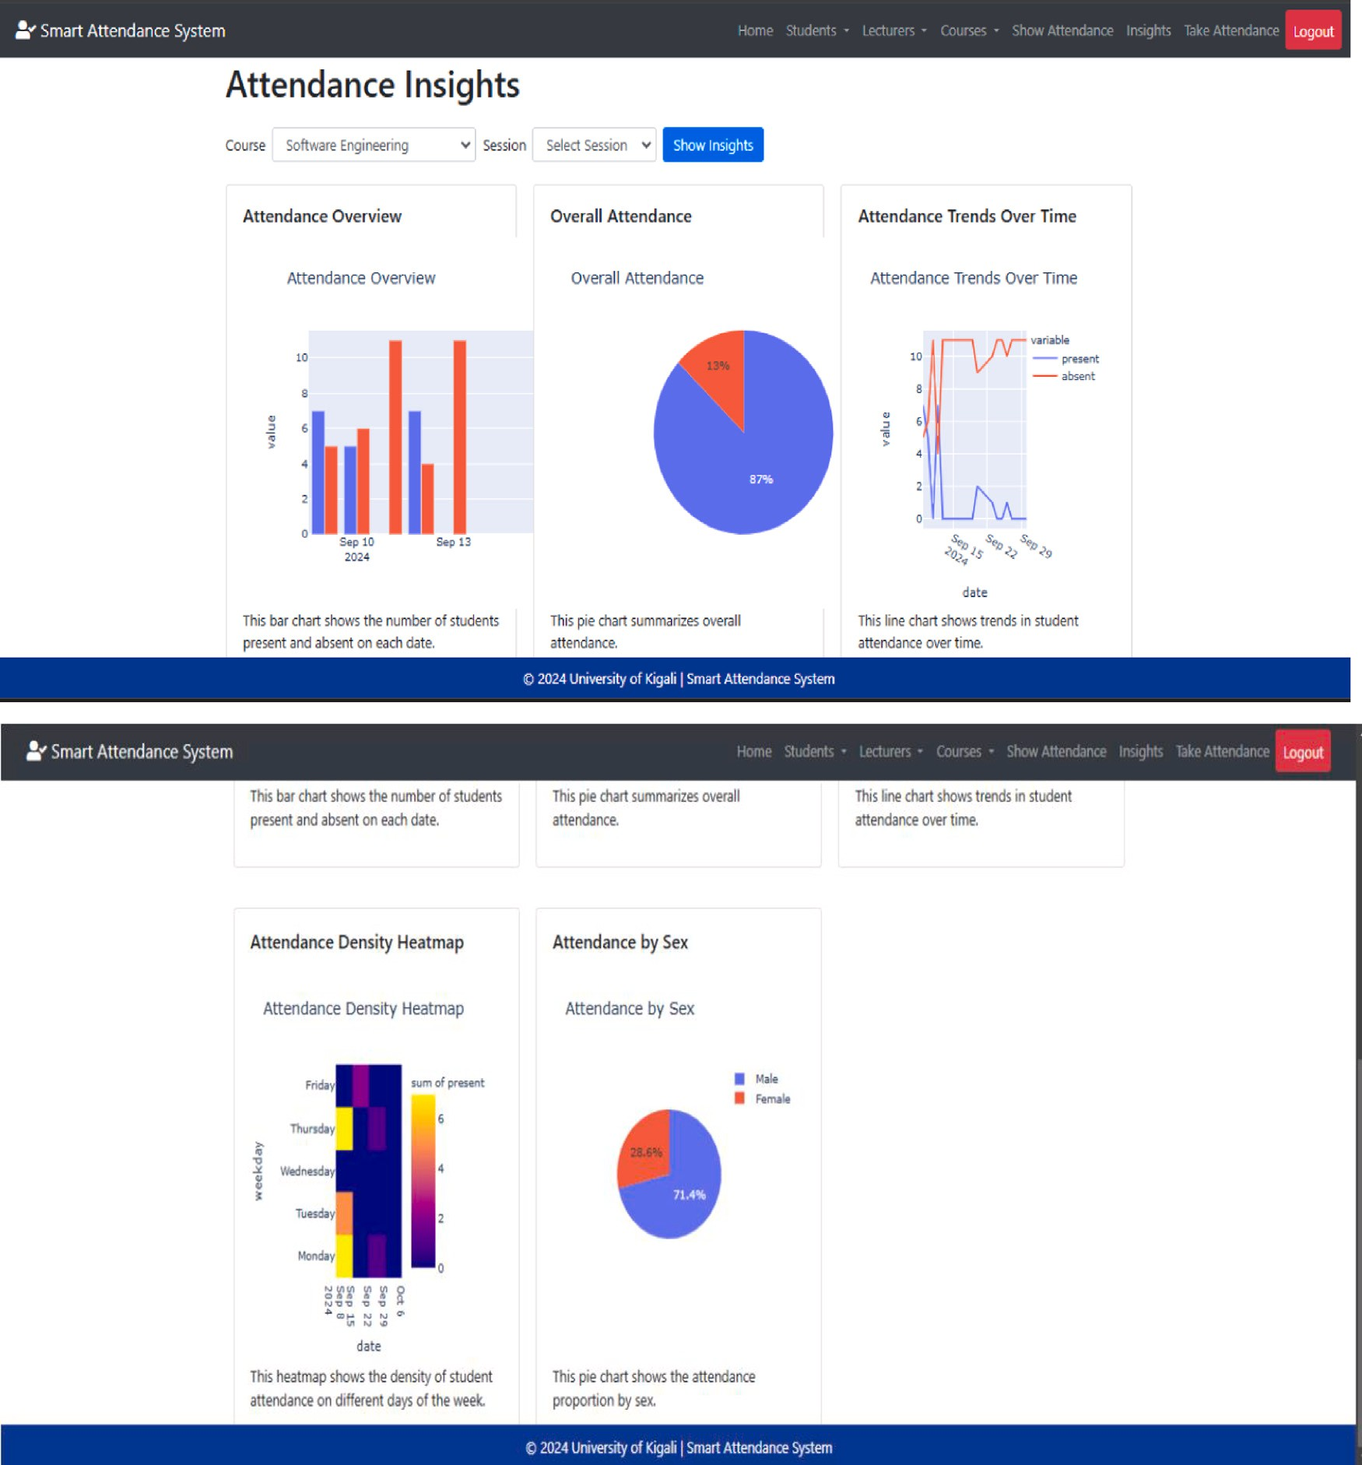

/ig. 5. Visual Insight Showing Student Attendance Trends Over Time.

    - Edge case analysis with individual examples
To further evaluate the system, edge cases were analyzed, particularly students who left early or were intermittently absent. The system successfully recorded attendance with 100% accuracy in cases where students did not meet the 80% minimum attendance threshold, ensuring that they were correctly marked as absent. This approach eliminates discrepancies and reinforces compliance with university attendance policies. A specific case observed involved a student leaving the class 10 min before the end of the session; since they had already attended more than 80% of the recorded attendance intervals, they were still marked as present. However, for students who attended less than 80% of the session, the system consistently recorded them as absent. This implementation ensures that attendance tracking is strictly based on participation requirements rather than just presence at isolated time points, eliminating potential manipulation or errors in attendance calculations.

    - Performance evaluation results
The proposed Real-Time Face Recognition Attendance System was evaluated using standard performance metrics, including accuracy, precision, Recall, F1-score, Processing Time, false acceptance rate (FAR), and false rejection rate (FRR). These metrics

Table 6
Summary of performance metrics.
Metric | Optimal condition | Challenging condition (Low light)
Face Detection Accuracy | 95% | 85%
Attendance Accuracy | 92.5% | –
Precision | 91.0% | 88.0%
Recall | 90.5% | 85.0%
F1-Score | 90.7% | 86.5%
Processing Time per Frame | 2.4 s | 6.1 s
False Acceptance Rate (FAR) | 2.5% | 5.0%
False Rejection Rate (FRR) | 3.1% | 7.0%

Table 7
Summary of attendance and recognition metrics across ten test sessions.
Session | Attendance accuracy (%) | Precision (%) | Recall (%) | F1-Score (%)
1 | 94.0 | 92.0 | 91.5 | 91.8
2 | 92.5 | 91.0 | 90.5 | 90.7
3 | 91.0 | 90.0 | 89.5 | 89.7
4 | 93.0 | 92.0 | 91.0 | 91.2
5 | 90.0 | 89.5 | 89.0 | 89.2
6 | 92.0 | 90.5 | 90.0 | 90.2
7 | 93.5 | 91.5 | 91.0 | 91.2
8 | 90.5 | 89.5 | 88.5 | 89.0
9 | 92.8 | 91.2 | 90.7 | 90.9
10 | 92.2 | 91.8 | 90.8 | 91.0
Average | 92.5 | 91.0 | 90.5 | 90.7

reflect the system’s ability to function effectively under real-world conditions, providing insights into its efficiency, robustness, and accuracy in tracking student attendance.
      - Accuracy and Recognition Performance: The system achieved an overall face recognition accuracy ranging from 94% to 88%, with a mean recognition accuracy of 91.3% and a standard deviation of 2.1% across 15 tested students. Under normal lighting conditions, the face detection accuracy was 95%, while in low-light environments, it slightly decreased to 85% (Table 2). These results demonstrate the system’s reliability in accurately recognizing students in various conditions.
      - Attendance Accuracy: The system recorded attendance with 92.5% accuracy, meaning it correctly marked students present in 92.5% of attendance instances. The system’s ability to enforce the 80% attendance threshold rule was 100% accurate, ensuring students who did not meet this requirement were correctly marked absent.
      - Precision and Recall: Precision measures the proportion of students correctly identified as present, while Recall evaluates the system’s ability to capture all students who were truly present. The system achieved a Precision of 91.0% and a Recall of 90.5%, indicating a well-balanced performance with minimal false positives and false negatives.
      - /1-Score: The harmonic mean of precision and recall was calculated as 90.7%, reinforcing the system’s robustness in recognizing and logging attendance while minimizing errors.
      - Processing Time: The average processing time per frame was 2.4 s, ensuring efficient real-time face recognition.
      - /alse Acceptance Rate (/AR) and /alse Rejection Rate (/RR): The system recorded a FAR of 2.5%, indicating a low number of incorrect matches. The FRR was observed at 3.1%, showing a minimal probability of valid students being missed by the system (see Table 6).

  - Test sessions

To enhance the reproducibility and transparency of the evaluation process, the system was tested across ten different sessions. Table 7 presents the detailed recognition accuracy obtained in each session. These results demonstrate the consistency and robustness of the system across multiple real-world scenarios.

    - Results and contributions
The proposed system significantly improves attendance management by addressing the limitations of traditional methods. Table 8 summarizes the key contributions and the corresponding results achieved.

  - Comparison with existing solutions

The proposed real-time face recognition-based attendance system demonstrates significant advancements compared to existing solutions. This section compares the system with notable approaches in the literature, focusing on accuracy, scalability, usability, and practical deployment.

Table 8
Summary of results and contributions.
Contribution Result/Impact

Improved accuracy and reliability of attendance tracking Real-time face recognition ensures precise
attendance logging, eliminating errors associated with manual or static systems.
Reduced risk of proxy attendance Continuous monitoring throughout the session prevents unauthorized attendance proxies.
Enhanced scalability and usability A web interface built with Flask provides an intuitive platform for managing attendance, adaptable to diverse educational settings.
Actionable insights through visual analytics Visualizations generated with Plotly offer detailed insights into attendance trends, supporting
informed decision-making by administrators and lecturers.

    - Accuracy
Existing face recognition systems, such as ‘‘DLFacer’’, utilize Faster Region Convolutional Neural Networks (FRCNN) to achieve high recognition accuracy rates between 97% and 99% under controlled environments [11]. Similarly, Dev and Patnaik reported a maximum accuracy of 97% using K-Nearest Neighbors (KNN) and 95% with Convolutional Neural Networks (CNNs) [20]. The proposed system achieves a recognition accuracy of 94% under optimal conditions and maintains 84% accuracy under less favorable scenarios, such as low-light environments. While slightly lower than ‘‘DLFacer’’ in ideal conditions, the system excels in real-world classroom settings, demonstrating robustness under varying lighting and crowd conditions (Tables 2 and 3).

    - Continuous monitoring
Many existing systems, including ‘‘DLFacer’’ and solutions by Yang and Han, capture attendance only at the start and end of sessions [13]. This limitation allows students to leave class early or rely on proxies. The proposed system overcomes this by recording attendance every 30 min and enforcing a presence threshold of 80% of the session, ensuring students remain engaged. This continuous monitoring provides a significant improvement in reducing proxy attendance.
An additional functional enhancement of our system is its ability to detect early departures automatically. Unlike traditional systems that only log a student’s presence once, our system continuously updates attendance status throughout the lecture, ensuring students who do not meet the 80% threshold are automatically marked absent. This was tested in multiple class sessions, and the system successfully recorded 100% accurate absence detection for students leaving early.

    - Scalability and usability
Zainal et al. highlighted issues with biometric systems like fingerprint scanners, which suffer scalability challenges in large classrooms due to physical interaction requirements and long verification times [6]. The proposed system eliminates these challenges using a contactless, face recognition-based approach. Moreover, the integration of Firebase for real-time data synchronization and Flask for a user-friendly web interface ensures the system is scalable to diverse educational settings and intuitive for end users.
Another major enhancement over existing solutions is the inclusion of role-based access control (RBAC) in our system. Unlike other solutions that focus only on student attendance, our system provides an administrative dashboard for university staff. This allows lecturers and administrators to manage course registrations, assign students to classes, and generate automated attendance reports. This feature was implemented based on university requirements and significantly improves system usability.

    - Visual analytics
Unlike traditional systems and face recognition-based solutions lacking analytics capabilities, the proposed system integrates Plotly to generate actionable insights. These visualizations, including attendance trends and session summaries, support data-driven decision-making for lecturers and administrators. No comparable functionality was reported in solutions like ‘‘DLFacer’’ or the system by Khan et al. [12].

    - Integration and automation
The proposed system’s ability to synchronize real-time attendance records and generate automated reports offers a distinct advantage over traditional and existing biometric systems. While many systems focus solely on detection and recognition, integrating Firebase and real-time updates ensures seamless operation and accessibility for stakeholders.
A key functional enhancement in our system is the ability to export attendance reports in multiple formats, including CSV, Excel, and PDF. Unlike existing solutions that only store attendance records in a database, our system allows instant report generation, making it more adaptable for administrative use. This feature was tested across multiple course sessions, and reports were generated accurately with zero data loss.

Table 9
Comparison of our system with existing solutions.
Feature | Existing solutions | Proposed system
Accuracy | 95% to 99% (ideal) [11,20], | 95% (optimal), 84% (low light)
Continuous Monitoring | Start and end only [13] | Every 30 min with 80% threshold
Scalability | Limited by hardware [6] | Contactless, scalable with Firebase
Visual Analytics | Absent [6,11–13,20,20,21] | Integrated with Plotly
Integration and Automation | Basic attendance tracking [6,11–13,20,20,21] | Real-time synchronization and automated reports

    - Summary of comparisons
  - Discussion

The real-time face recognition-based attendance system has the potential to make a significant impact on educational institutions and society at large. Automating attendance tracking eliminates the inefficiencies and inaccuracies associated with traditional methods, such as manual roll calls or sign-ins, fostering a culture of accountability and active student participation. This improvement enhances the quality of education by encouraging consistent attendance, which is directly linked to better academic performance [31].
The contactless nature of the system addresses modern societal concerns about hygiene and safety, particularly in the aftermath of the COVID-19 pandemic. The system promotes a safer and more hygienic environment, especially in densely populated classrooms, by reducing physical interaction and reliance on shared devices such as fingerprint scanners. Additionally, its ability to operate in real-time ensures that attendance data is always up to date, streamlining administrative processes and reducing the workload for teachers and administrative staff.
From a technological perspective, integrating real-time analytics in the system empowers institutions to make data-driven decisions. The insights generated by the system allow educators to identify attendance trends and take proactive measures to address issues such as truancy or disengagement. Over time, these interventions improve educational outcomes, benefiting individuals and the broader community.
Furthermore, the system’s scalability makes it a valuable tool for large educational institutions, smaller organizations, and community programs. Its deployment can extend beyond classrooms to applications such as workforce management, event monitoring, and public service delivery, demonstrating its versatility and societal relevance.

Conclusion

This research demonstrates the feasibility and practicality of a real-time face recognition-based attendance system tailored to educational settings. By addressing inefficiencies inherent in traditional methods and overcoming limitations observed in earlier biometric solutions, the system offers a transformative approach to attendance management, as shown in Table 9. Its innovative features, including continuous tracking and real-time data synchronization, set a new standard for accuracy, accountability, and operational efficiency.
Integrating Firebase for automated data handling and Plotly for visual analytics ensures that attendance records are precise and actionable. These capabilities empower educators and administrators to make informed decisions based on reliable data while streamlining administrative processes. Furthermore, the system’s design emphasizes scalability and usability, making it adaptable to many classroom environments, from small learning centers to large educational institutions.
Future enhancements could address limitations such as low-light performance. They could incorporate advanced imaging techniques and high-definition sliding cameras to improve facial detection and recognition under challenging conditions.
In conclusion, this study significantly contributes to the evolution of more innovative, contactless attendance management solutions. The system’s versatility and scalability extend beyond educational institutions to other sectors, such as workforce management and event monitoring, reinforcing its relevance and societal impact. This research lays a strong foundation for future exploration and broader adoption in real-world applications.

CRediT authorship contribution statement

Emmanuel Bugingo: Writing – review & editing, Writing – original draft, Supervision, Resources, Project administration, Methodology, Formal analysis, Data curation, Conceptualization. Obed Imbahafi: Writing – original draft, Conceptualization. Ath- natius Caius Umeonyirioha: Methodology. Tohari Ahmad: Writing – review & editing, Methodology, Investigation. Ntivuguruzwa Jean De La Croix: Writing – review & editing, Investigation, Formal analysis, Conceptualization. Anne Marie Uwumuremyi: Writing – review & editing, Data curation.

Declaration of competing interest

The authors declare that there are no known financial, professional, or personal conflicts of interest that could have influenced the research presented in this paper.

Acknowledgments

We are truly grateful to God Almighty for the gift of life. Our deepest gratitude goes out to everyone who contributed to the success of this study and whose counsel and support were essential to its completion. The authors note that Grammarly was used to refine the manuscript’s wording.

Data availability

Data will be made available on request.

References

- A. Strickley, Attendance records, educational management, in: A. Tatnall (Ed.), Encyclopedia of Education and Information Technologies, Springer, Cham, 2020, pp. 195–202, http://dx.doi.org/10.1007/978-3-030-10576-1_117.
- S. Gershenson, Linking teacher quality, student attendance, and student achievement, Educ. Financ. Policy 11 (2) (2016) 125–149, http://dx.doi.org/10.
1162/EDFP_a_00180, arXiv:https://direct.mit.edu/edfp/article-pdf/11/2/125/1690190/edfp_a_00180.pdf.
- S. Mansoora, G. Sadineni, S. Kauser, Attendance management system using face recognition method, J. Phys.: Conf. Ser. 2089 (2021) 012078, http://dx.doi.org/10.1088/1742-6596/2089/1/012078.
- S. Singh, S.C.K. Chintalacheruvu, S. Garg, Y. Giri, M. Kumar, Efficient face identification and authentication tool for biometric attendance system, in: 2021
8th International Conference on Signal Processing and Integrated Networks, SPIN, 2021, pp. 379–383, http://dx.doi.org/10.1109/SPIN52536.2021.9565990.
- E.S.K. Siew, Z.Y. Chong, S.N. Sze, R. Hardi, Streamlining attendance management in education: A web-based system combining facial recognition and QR code technology, J. Adv. Res. Appl. Sci. Eng. Technol. 33 (2) (2023) 198–208, http://dx.doi.org/10.37934/araset.33.2.198208.
- N.I. Zainal, K.A. Sidek, T.S. Gunawan, H. Manser, M. Kartiwi, Design and development of portable classroom attendance system based on arduino and
fingerprint biometric, in: The 5th International Conference on Information and Communication Technology for the Muslim World (ICT4M), 2014, pp. 1–4, http://dx.doi.org/10.1109/ICT4M.2014.7020601.
- B.K.P. Mohamed, C.V. Raghu, Fingerprint attendance system for classroom needs, in: 2012 Annual IEEE India Conference, INDICON, 2012, pp. 433–438,
http://dx.doi.org/10.1109/INDCON.2012.6420657.
- M. Alhothaily, M. Alradaey, M. Oqbah, A. El-Kustaban, Fingerprint attendance system for educational institutes, J. Sci. Technol. 20 (1) (2015) 34–44, http://dx.doi.org/10.20428/jst.v20i1.842.
- S. Rahman, M. Rahman, M.M. Rahman, Automated student attendance system using fingerprint recognition, Edelweiss Appl. Sci. Technol. 2 (1) (2018)
90–94, http://dx.doi.org/10.33805/2576.8484.120.
- S. Dey, S. Barman, R.K. Bhukya, R.K. Das, B.C. Haris, S.R.M. Prasanna, R. Sinha, Speech biometric based attendance system, in: 2014 Twentieth National Conference on Communications, NCC, 2014, pp. 1–6, http://dx.doi.org/10.1109/NCC.2014.6811345.
- E. Ogbuju, A. Adetayo, P. Oblikwu, A face recognition system for attendance record a face recognition system for attendance record in a Nigerian university,
J. Sci. Res. Dev. 19 (2020) 38–45.
- S. Khan, A. Akram, N. Usman, Real time automatic attendance system for face recognition using face API and OpenCV, Wirel. Pers. Commun. 113 (2020) 469–480, http://dx.doi.org/10.1007/s11277-020-07224-2.
- H. Yang, X. Han, Face recognition attendance system based on real-time video processing, IEEE Access 8 (2020) 159143–159150, http://dx.doi.org/10.
1109/ACCESS.2020.3007205.
- M. Ali, A. Diwan, D. Kumar, Attendance system optimization through deep learning face recognition, Int. J. Comput. Digit. Syst. 15 (1) (2024) 1527–1540.
- M. Arsenovic, S. Sladojevic, A. Anderla, D. Stefanovic, FaceTime — Deep learning based face recognition attendance system, in: 2017 IEEE 15th International Symposium on Intelligent Systems and Informatics, SISY, 2017, pp. 000053–000058, http://dx.doi.org/10.1109/SISY.2017.8080587.
- A.K. Shukla, A. Shukla, R. Singh, Automatic attendance system based on CNN–LSTM and face recognition, Int. J. Inf. Technol. 16 (3) (2024) 1293–1301,
http://dx.doi.org/10.1007/s41870-023-01495-1.
- G. Venkatakrishnan, R. Rengaraj, R. Jeya, S.K. R, M. S, D.D. N, M.A. A, Design and implementation of automated attendance system using contactless facial recognition, in: 2024 International Conference on Power, Energy, Control and Transmission Systems, ICPECTS, 2024, pp. 1–6, http://dx.doi.org/10. 1109/ICPECTS62210.2024.10780113.
- B. Dani, T. Alex, M.P.V. Naisam, G. Melbin, H. Shihabudeen, et al., Cloud-based storage solutions for facial recognition attendance systems, in: 2024
7th International Conference on Circuit Power and Computing Technologies, ICCPCT, vol. 1, IEEE, 2024, pp. 1610–1615, http://dx.doi.org/10.1109/ ICCPCT61902.2024.10672628.
- B.-T. Nguyen-Tat, M.-Q. Bui, V.M. Ngo, Automating attendance management in human resources: A design science approach using computer vision and
facial recognition, Int. J. Inf. Manag. Data Insights 4 (2) (2024) 100253, http://dx.doi.org/10.1016/j.jjimei.2024.100253.
- S. Dev, T. Patnaik, Student attendance system using face recognition, in: 2020 International Conference on Smart Electronics and Communication, ICOSEC, 2020, pp. 90–96, http://dx.doi.org/10.1109/ICOSEC49089.2020.9215441.
- J. Rusdi, F.R. Kodong, R. Indrajit, H. Sofyan, Abdurrohman, R. Marco, Student attendance using face recognition technology, 2020, pp. 1–4, http:
//dx.doi.org/10.1109/ICORIS50180.2020.9320819.
- U. Essien, G. Ansa, Attendance-based systems for face recognition using a camera rail approach, Res. J. Sci. Technol. 3 (1) (2023) 14–28.
- M. Patil, M. Karhe, M. Jain, Student attendance recording system using face recognition with GSM based, Int. J. Res. Advent Technol. 2 (8) (2014) 32–35.
- I. Culjak, D. Abram, T. Pribanic, H. Dzapo, M. Cifrek, A brief introduction to opencv, in: 2012 Proceedings of the 35th International Convention MIPRO, 2012, pp. 1725–1730, [Online]. Available: https://ieeexplore.ieee.org/abstract/document/6240859.
- A. Geitgey, Machine learning is fun! Part 4: Modern face recognition with deep learning, 2018, [Online]. Available: https://medium.com/@ageitgey/
machine-learning-is-fun-part-4-modern-face-recognition-with-deep-learning-c3cffc121d78. (Accessed: 2024-11-07).
- Python Basics, What is flask Python?, 2021, [Online]. Available: https://pythonbasics.org/what-is-flask-python/. (Accessed: 2024-11-07).
- L. Moroney, The firebase realtime database, in: The Definitive Guide To Firebase: Build Android Apps on Google’s Mobile Platform, Apress, Berkeley, CA, 2017, pp. 51–71, http://dx.doi.org/10.1007/978-1-4842-2943-9_3.
- L. Addepalli, L. Gaurav, S. Sindhuja, S. Hussain, M. Joydeep, V. Uppalapati, W. Ali, V. Sagar, Assessing the performance of python data visualization
libraries: A review, Int. J. Comput. Eng. Res. Trends 10 (2023) 28–39, http://dx.doi.org/10.22362/ijcert/2023/v10/i01/v10i0104.
- E. Anello, Introduction to NumPy and Pandas, KDnuggets, 2023, [Online]. Available: https://www.kdnuggets.com/introduction-to-numpy-and-pandas. (Accessed: 2025-01-07).
- S. Neeharika, S. Ravikishan, M. Ankitha, Development of an android-based attendance and academic progress tracking system with parent interaction, in:
2023 6th International Conference on Recent Trends in Advance Computing, ICRTAC, 2023, pp. 71–77, http://dx.doi.org/10.1109/ICRTAC59277.2023. 10480810.
- R.F. Ancheta, D. Daniel, R. Ahmad, Effect of class attendance on academic performance, Eur. J. Educ. Stud. 8 (9) (2021) http://dx.doi.org/10.46827/ejes.
v8i9.3887.

